|  |  |
| --- | --- |
| **Date** | 23/06/2025 |
| **Team Id** | LTVIP2025TMID31079 |
| **Project Name** | Medical Inventory Management |
| **College Name** | IDEAL INSTITUTE OF TECHNOLOGY, KAKINADA |

**Step 1: Team Gathering, Collaboration, and Problem Statement Selection**

To begin the brainstorming session for the Medical Inventory Management System project, our team followed a collaborative approach to identify a relevant and impactful problem statement. This foundational step helped ensure that the entire team was aligned on the goal and scope of the system we intended to build.

|  |
| --- |
| * **Activities Involved:** |

**Team Gathering**

● Scheduled a virtual meeting using Google Meet.

● All team members were briefed about the purpose of the brainstorming session

**Collaboration Setup**

● Created a shared Google Doc for note-taking.

● Used tools like Jam board and Mural for idea visualization

**Discussion and Idea Exchange**

Each member shared initial thoughts on current issues in medical systems (e.g. manual errors, stock visibility, usage of expired medicines, etc…).

● Each member shared initial thoughts on current issues in airline systems (e.g., manual errors, stock visibility, usage of expired medicines, etc…).

● Ideas were recorded on sticky-note-like cells for visibility

**Finalizing the Problem Statement**

After evaluating different perspectives, we agreed on the following problem statement:

💡 **"How might we design a Medical Inventory Management System that enhances user Medical experience, Real-time inventory tracking dashboard, Mobile app for inventory management, and reduces customer service delays?"**

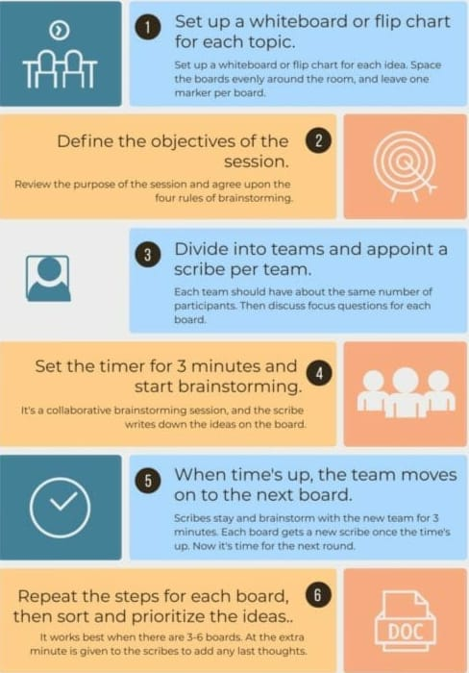**Key Rules of Brainstorming**

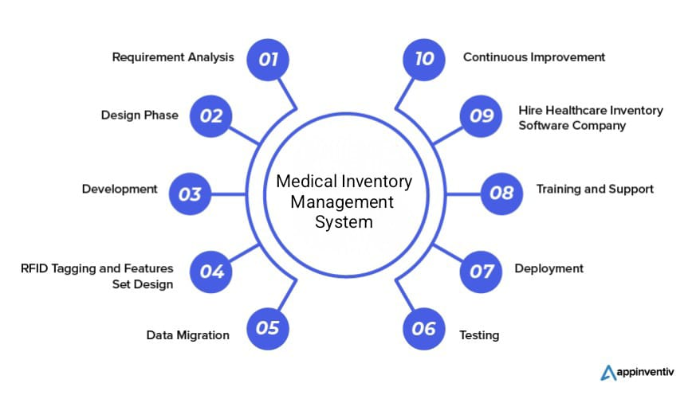**Step-2: Brainstorm, Idea Listing and Grouping**

**Step-3: Idea Prioritization**

|  |  |  |  |
| --- | --- | --- | --- |
| Idea No. | Idea description | Benefits | Feasibility (High/Medium/  Low) |
| 1. | Automated barcode Scanning for Medicines | Reduces manual errors and saves time | High |
| 2. | Real-time inventory tracking dashboard | Provides up-to-date stock visibility | Medium |
| 3. | Expiry alerts via SMS/email | Prevents usage of expired medicines | High |
| 4. | Mobile app for inventory management | Increases accessibility and flexibility | Medium |

**Problem Statement**

User Problems:

●Difficulty with expired medicines.

● No clear accessibility or flexibility.

● Difficulty in cancellations or refunds.

Admin Problems:

● Managing stock visibility and staff is time-consuming.

● Inadequate data tracking and reporting tools.

● Lack of centralized control for notifications or changes.

**Empathy** **map**

**Understanding user needs for a better medical experience**